Project Planning Phase
Project Planning Template (Product Backlog, Sprint Planning, Stories, Story points)

Date | 30 September 2026
Team ID | SWTID-2026-9109
Project Name | AI FITTRACK API
Maximum Marks | 5 Marks

Product Backlog, Sprint Schedule, and Estimation (4 Marks)
Use the below template to create product backlog and sprint schedule
Sprint | Functional Requirement (Epic) | User Story Number | User Story / Task | Story Points | Priority | Team Members
Sprint-1 | Registration | USN-1 | As a user, I can register by entering my email, password and confirming my password. | 2 | High | Member 1
Sprint-1 |  | USN-2 | As a user, I will receive a confirmation email once I have registered. | 1 | High | Member 1
Sprint-1 |  | USN-3 | As a user, I can register through my Google account. | 2 | Medium | Member 2
Sprint-1 | Login | USN-4 | As a user, I can log in with email and password and receive a secure token (JWT). | 2 | High | Member 2
Sprint-1 |  | USN-5 | As a user, I can reset my password if I forget it. | 2 | Medium | Member 3
Sprint-1 | Profile | USN-6 | As a user, I can create my profile with age, height, weight and fitness goal. | 3 | High | Member 3
Sprint-1 | Dashboard | USN-7 | As a user, I can view a dashboard summary of my activity. | 3 | Medium | Member 4
Sprint-1 | Developer Access | USN-8 | As a developer, I can get an API key and read the OpenAPI (Swagger) documentation. | 5 | High | Member 1
Sprint-2 | Workout Tracking | USN-9 | As a user, I can log a workout with exercise, sets, reps and duration. | 3 | High | Member 1
Sprint-2 |  | USN-10 | As a user, I can view, edit and delete my workout history. | 3 | High | Member 2
Sprint-2 | Nutrition Tracking | USN-11 | As a user, I can log meals with calories and macros. | 3 | High | Member 3
Sprint-2 |  | USN-12 | As a user, I can view my daily nutrition summary. | 2 | Medium | Member 3
Sprint-2 | Sleep & Activity | USN-13 | As a user, I can log my sleep hours and daily steps. | 2 | Medium | Member 4
Sprint-2 | Goals | USN-14 | As a user, I can set a fitness goal with a target date. | 2 | High | Member 2
Sprint-2 | Integration | USN-15 | As a user, I can sync my data from a wearable / Google Fit. | 5 | Low | Member 4
Sprint-3 | AI Recommendations | USN-16 | As a user, I receive a personalised weekly workout plan. | 5 | High | Member 1
Sprint-3 |  | USN-17 | As a user, I receive recommended calorie and macro targets. | 3 | High | Member 2
Sprint-3 |  | USN-18 | As a user, I get an alert when I hit a plateau or risk overtraining. | 3 | Medium | Member 3
Sprint-3 |  | USN-19 | As a user, I can ask fitness questions to an AI coach endpoint. | 5 | Low | Member 4
Sprint-3 | Progress Reports | USN-20 | As a user, I can view a weekly progress report. | 4 | High | Member 2
Sprint-4 | Notifications | USN-21 | As a user, I receive reminders for workouts and meals. | 3 | Medium | Member 3
Sprint-4 | Progress Reports | USN-22 | As a user, I can view trend charts and export my data as CSV. | 3 | Low | Member 4
Sprint-4 | Administration | USN-23 | As an administrator or customer care executive, I can look up and manage users, and monitor API usage. | 4 | Medium | Member 1
Sprint-4 | Security | USN-24 | As a system owner, I want rate limiting and audit logging to protect the API. | 3 | High | Member 2
Sprint-4 | Testing | USN-25 | As a team, we run automated tests and fix bugs found in UAT. | 3 | High | Member 3
Sprint-4 | Deployment | USN-26 | As a team, we deploy the API to the cloud with a CI/CD pipeline. | 4 | High | Member 4

Project Tracker, Velocity & Burndown Chart: (4 Marks)
Sprint | Total Story Points | Duration | Sprint Start Date | Sprint End Date (Planned) | Story Points Completed (as on Planned End Date) | Sprint Release Date (Actual)
Sprint-1 | 20 | 6 Days | 05 Oct 2026 | 10 Oct 2026
Sprint-2 | 20 | 6 Days | 12 Oct 2026 | 17 Oct 2026
Sprint-3 | 20 | 6 Days | 19 Oct 2026 | 24 Oct 2026
Sprint-4 | 20 | 6 Days | 26 Oct 2026 | 31 Oct 2026

Velocity:
Imagine we have a 10-day sprint duration, and the velocity of the team is 20 (points per sprint). Let’s calculate the team’s average velocity (AV) per iteration unit (story points per day)

For AI FITTRACK API: 4 sprints x 20 story points = 80 story points in total. With a sprint duration of 6 days and a planned velocity of 20 story points per sprint, the average velocity (AV) = 20 / 6 = 3.33 story points per day.

Burndown Chart:
A burn down chart is a graphical representation of work left to do versus time. It is often used in agile software development methodologies such as Scrum. However, burn down charts can be applied to any project containing measurable progress over time.
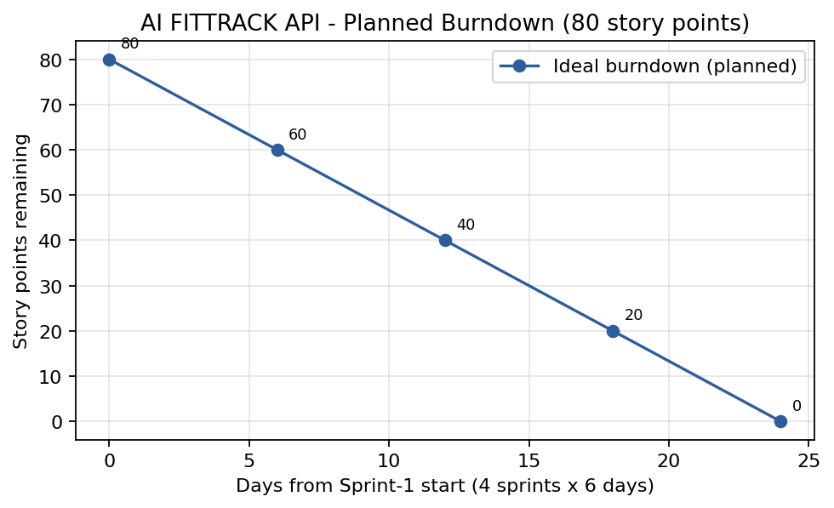
Planned (ideal) burndown for the 80 story points. The actual line will be added as sprints are completed.

https://www.visual-paradigm.com/scrum/scrum-burndown-chart/
https://www.atlassian.com/agile/tutorials/burndown-charts

Reference:
https://www.atlassian.com/agile/project-management
https://www.atlassian.com/agile/tutorials/how-to-do-scrum-with-jira-software
https://www.atlassian.com/agile/tutorials/epics
https://www.atlassian.com/agile/tutorials/sprints
https://www.atlassian.com/agile/project-management/estimation
https://www.atlassian.com/agile/tutorials/burndown-charts

